ORALSCAN AI
AI_C1 Classifier
Complete Study & Technical Reference
Final system: Dual-ROI EfficientNetV2-B3 classifier integrated with AI_Y1 YOLO segmentation
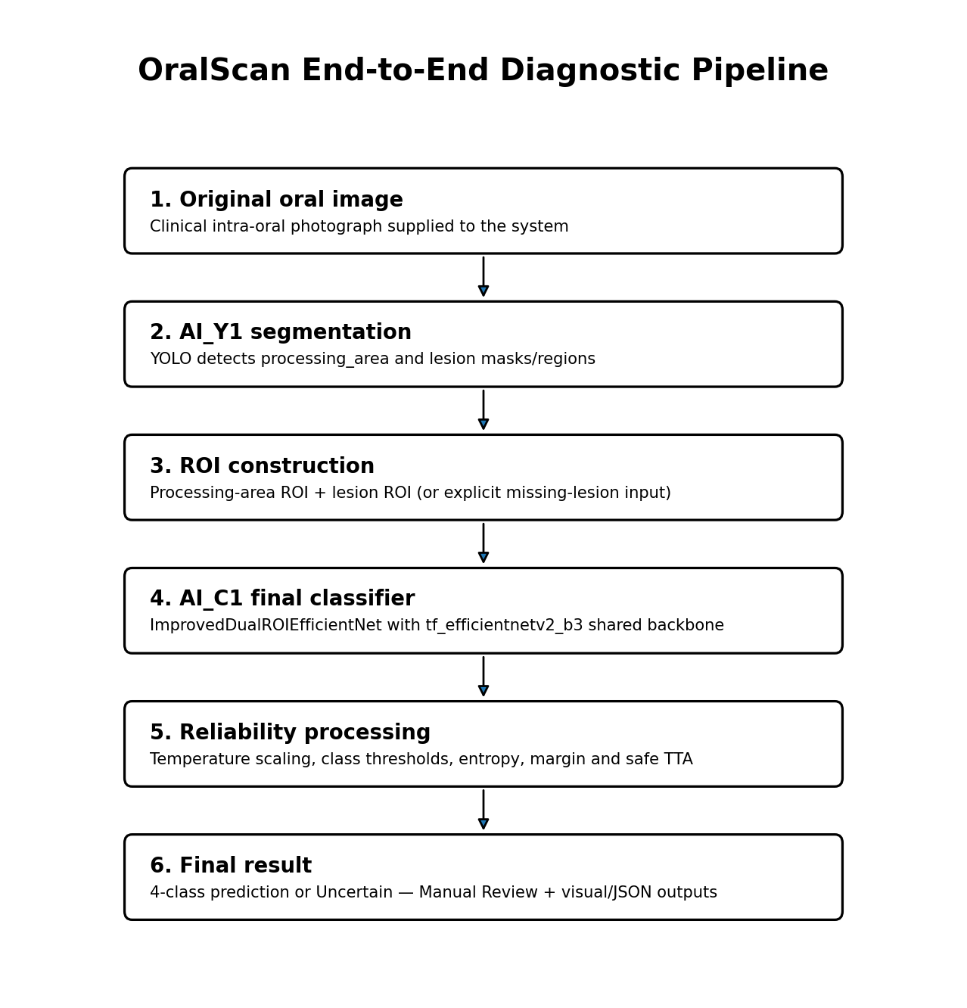
Source basis: ai_c1(4).ipynb and its recorded execution outputs

1. Executive Summary
AI_C1 is the diagnostic classification stage of OralScan. It does not replace AI_Y1; it consumes regions produced by AI_Y1. The final upgraded classifier is a single model named ImprovedDualROIEfficientNet with a pretrained tf_efficientnetv2_b3 backbone. “Dual-ROI” means one classifier receives two related image inputs: the processing-area ROI and the lesion ROI.
Component | Final role | Model / output
AI_Y1 | Segmentation / ROI localization | Single YOLO segmentation model → processing_area + lesion
AI_C1 | 4-class diagnostic classification | ImprovedDualROIEfficientNet → Cancer / Leukoplakia / Leukoplakia-like Conditions / Normal Buccal Mucosa
Reliability layer | Decision support | Calibration, thresholds, uncertainty, safe TTA, hard-case/manual-review logic

The notebook also contains an earlier single-ROI EfficientNetV2-B3 baseline. That baseline has recorded test results. The later Dual-ROI V2 architecture is the intended final classifier used by the V4 inference pipeline; however, its completed training/test numeric outputs are not preserved in the notebook output cells. This document therefore separates measured baseline results from final-architecture configuration.

2. Where AI_C1 Fits in the Complete OralScan System
The critical dependency is AI_Y1 → AI_C1. AI_Y1 identifies oral tissue regions. AI_C1 then uses these anatomically focused regions instead of treating the complete photograph as an undifferentiated classification image.

3. Classification Problem Definition
Class index | Frozen class name | Meaning in classifier
0 | Cancer | Cancer diagnostic class
1 | Leukoplakia | Leukoplakia diagnostic class
2 | Leukoplakia-like Conditions | Conditions visually resembling leukoplakia
3 | Normal Buccal Mucosa | Normal buccal mucosa class

The class order is explicitly frozen in the notebook and must remain unchanged when loading checkpoints or interpreting logits.

4. Raw Classification Dataset
Class | Raw valid images | Share
Cancer | 1,776 | 48.10%
Leukoplakia | 331 | 8.97%
Leukoplakia-like Conditions | 218 | 5.90%
Normal Buccal Mucosa | 1,367 | 37.03%
Total | 3,692 | 100%

All 3,692 discovered images passed the notebook image validation stage; zero invalid images were reported. The distribution is strongly imbalanced: the smallest class (Leukoplakia-like Conditions) is much smaller than Cancer and Normal Buccal Mucosa.

4.1 Why duplicate cleaning was necessary
For a medical image classifier, exact duplicate images can cause leakage if copies land in different splits. More critically, an identical image appearing under different class labels creates contradictory supervision. The notebook therefore hashes every source image with SHA-1 before splitting.
Audit item | Recorded result
Initial records | 3,692
Unique image hashes before cleaning | 3,516
Duplicate records | 342
Duplicate hash groups | 166
Conflicting hash groups | 145
Rows involved in label conflicts | 298
Same-class duplicate copies removed after conflict removal | 23
Final clean unique images | 3,371

5. Leakage-Safe Dataset Preparation
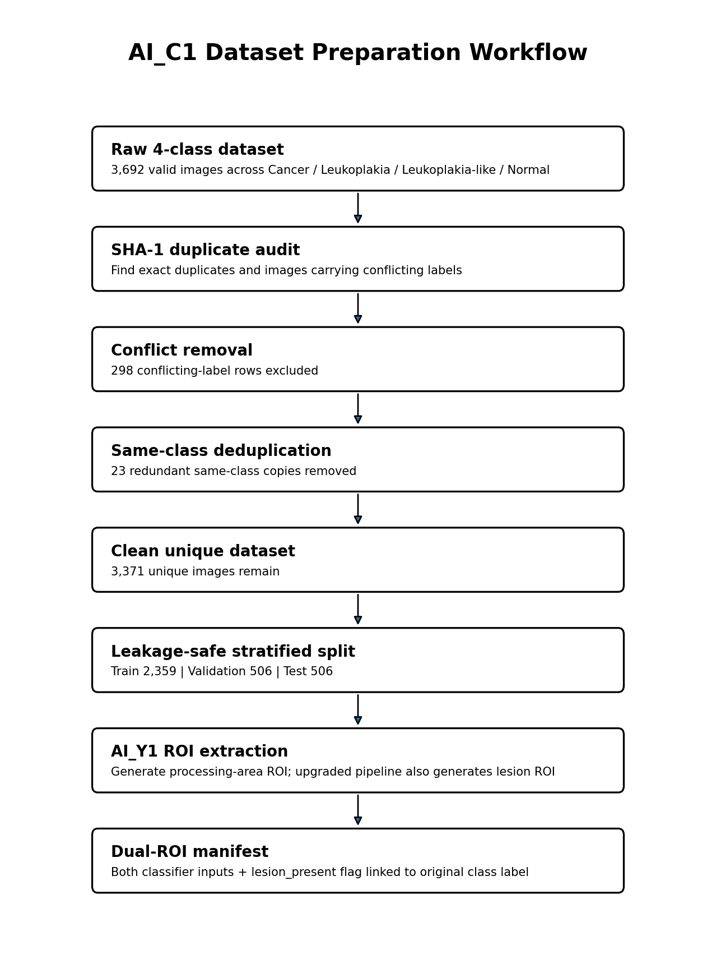
Class | Train | Validation | Test | Clean total
Cancer | 1,121 | 240 | 241 | 1,602
Leukoplakia | 178 | 38 | 38 | 254
Leukoplakia-like Conditions | 103 | 23 | 22 | 148
Normal Buccal Mucosa | 957 | 205 | 205 | 1,367
Total | 2,359 | 506 | 506 | 3,371

The split is stratified and performed after removal of conflicting labels and redundant exact copies. The notebook explicitly verifies that no exact duplicate and no split leakage remains.

6. AI_Y1-Based ROI Generation
The classifier data pipeline loads the trained AI_Y1 segmentation model. The YOLO mapping detected by the notebook is 0 = processing_area and 1 = lesion. For the first classifier version, AI_Y1 generated processing-area crops for all 3,371 clean images.
ROI source | Cancer | Leukoplakia | Leukoplakia-like | Normal | Interpretation
processing_area_mask | 1,545 | 243 | 147 | 1,362 | YOLO processing-area detection used
full_image_fallback | 57 | 11 | 1 | 5 | Full image used when processing-area ROI unavailable

All 3,371 images successfully produced a classifier input. Full-image fallback occurred for 2.20% of the dataset, so no sample was lost at this stage.

7. Baseline AI_C1 Classifier (Earlier Version)
Before the final Dual-ROI upgrade, the notebook trained a conventional single-input classifier on processing-area ROI images. This version is useful as a measured baseline and as evidence that the dataset/training pipeline was operational.
Setting | Baseline value
Architecture | tf_efficientnetv2_b3
Input | Single processing-area ROI
Input size | 300 × 300
Parameters | 12,827,554
Batch size | 32
Max epochs | 80
Optimizer | AdamW
Initial LR | 3e-4
Minimum LR | 1e-6
Weight decay | 1e-4
Loss | Weighted CrossEntropy + label smoothing 0.10
Scheduler | CosineAnnealingLR
Mixed precision | Enabled
Early-stopping patience | 12
Best checkpoint | ai_c1_efficientnetv2_b3_best.pt

7.1 Recorded baseline performance
The best validation Macro-F1 occurred at epoch 18 (0.748529). The final evaluation was performed on the 506-image test split.
Metric | Recorded test value
Accuracy | 0.8933
Macro Precision | 0.7673
Macro Recall | 0.7307
Macro F1 | 0.7431
Mean inference time | 0.86 ms/image
Macro ROC-AUC | Not available in recorded run

Class | Precision | Recall | F1 | Support
Cancer | 0.9375 | 0.9336 | 0.9356 | 241
Leukoplakia | 0.6500 | 0.6842 | 0.6667 | 38
Leukoplakia-like Conditions | 0.5714 | 0.3636 | 0.4444 | 22
Normal Buccal Mucosa | 0.9104 | 0.9415 | 0.9257 | 205

Study interpretation: the baseline performed strongly on Cancer and Normal Buccal Mucosa, while the smallest Leukoplakia-like class remained difficult. This class-imbalance/small-sample problem is one reason the later pipeline adds more deliberate balancing and dual-ROI information.

8. Final Classifier Selected for OralScan
The final classifier used by the upgraded inference code is not a second YOLO and not two separate classifiers. It is one dual-input neural network: ImprovedDualROIEfficientNet, based on tf_efficientnetv2_b3.
Item | Final setting
Model ID | ai_c1_dual_roi_v2
Class name in code | ImprovedDualROIEfficientNet
Backbone | tf_efficientnetv2_b3
Number of classes | 4
Image size | 300 × 300 for each ROI
Dropout | 0.35
Final inference checkpoint | UPGRADE_BEST_F1_PATH → ai_c1_dual_roi_v2_best_macro_f1.pt

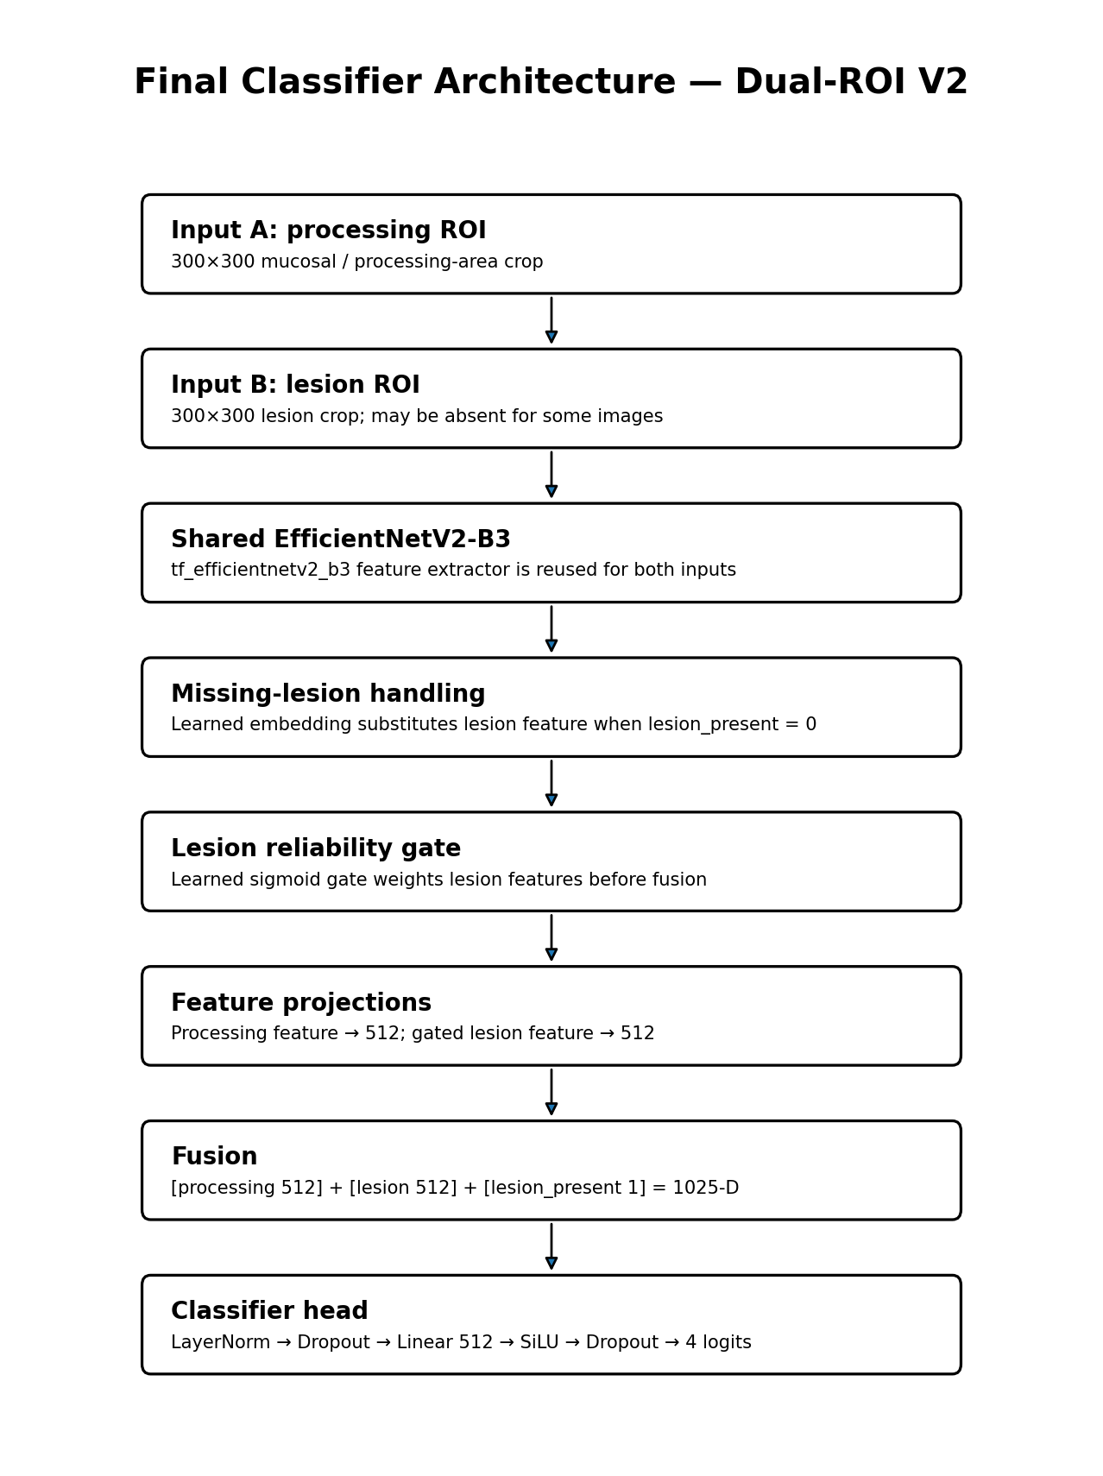

9. How the Dual-ROI Model Works

9.1 Shared feature extractor
Both processing ROI and lesion ROI pass through the same pretrained EfficientNetV2-B3 backbone configured with num_classes=0 and global average pooling. This produces feature vectors rather than class logits.

9.2 Learned missing-lesion embedding
A lesion is not guaranteed to be detected in every image. Instead of forcing a meaningless lesion crop, the model contains a learned feature vector called missing_lesion_embedding. When lesion_present = 0, this learned vector replaces the observed lesion feature.

9.3 Lesion reliability gate
The lesion feature and lesion_present indicator are fed to a small neural gate ending in Sigmoid. The resulting scalar weight controls how strongly lesion information contributes to the final decision. This is a learned reliability mechanism rather than a fixed rule.

9.4 Projection and fusion
Processing features are projected to 512 dimensions. Gated lesion features are independently projected to 512 dimensions. The model concatenates processing 512 + lesion 512 + one lesion_present value, producing a 1,025-dimensional fused representation.

9.5 Classification head
The fused vector is normalized, regularized with dropout, reduced through a 512-unit SiLU layer, and mapped to four output logits. Softmax probabilities are applied later during inference/calibration.

10. Upgraded Dual-ROI Dataset Behavior
The upgraded dataset links each clean source image with two possible ROI files: processing ROI and lesion ROI, plus the original diagnostic label and a lesion_present indicator. Training can intentionally drop the lesion branch with probability 0.15, forcing the network to remain useful when lesion localization is unavailable or uncertain.
- Processing ROI is the stable contextual tissue input.
- Lesion ROI provides local disease-specific visual evidence when available.
- lesion_present explicitly tells the model whether lesion information is real or substituted.
- The missing-lesion embedding prevents absence from being represented as an arbitrary image.
- Branch dropout improves robustness to imperfect real-world segmentation.

11. Training Strategy for the Final Dual-ROI Model
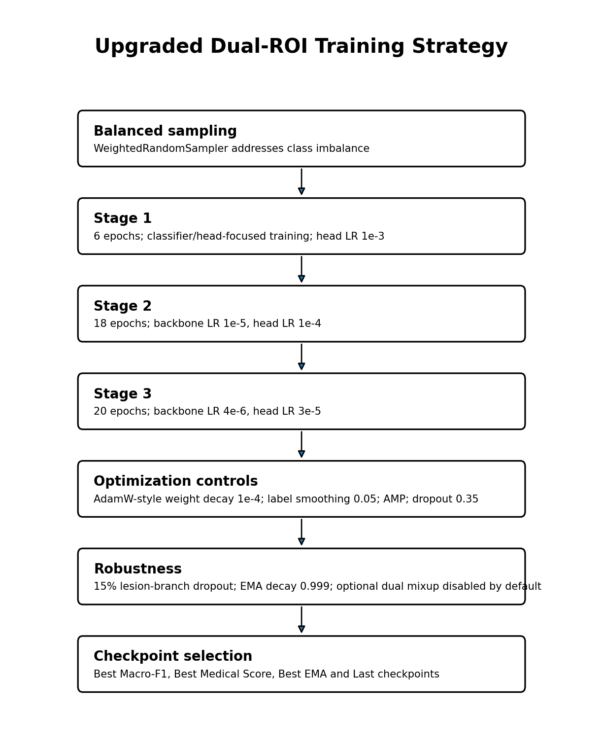
Parameter | Final upgraded configuration
Batch size | 16
Workers | 2
Stage 1 epochs | 6
Stage 2 epochs | 18
Stage 3 epochs | 20
Stage 1 head LR | 1e-3
Stage 2 backbone / head LR | 1e-5 / 1e-4
Stage 3 backbone / head LR | 4e-6 / 3e-5
Weight decay | 1e-4
Label smoothing | 0.05
Dropout | 0.35
Early stopping | 10
Lesion branch dropout | 0.15
EMA decay | 0.999
Dual mixup | Implemented but disabled by default

12. Class Imbalance Handling
The earlier baseline used class-weighted CrossEntropy. In the upgraded training cell, the strategy changes: WeightedRandomSampler balances training batches, while the loss becomes ordinary CrossEntropy with label smoothing 0.05. The code explicitly notes that strong class weights are not applied again because the sampler already balances classes.
This avoids “double compensation,” where both aggressive sampling and aggressive loss weighting could over-amplify minority-class gradients.

13. EMA and Checkpoint Strategy
An exponential moving average (EMA) copy of the model is maintained with decay 0.999. EMA smooths parameter updates and can produce a more stable evaluation model. The notebook defines four checkpoint families:
Checkpoint | Purpose
ai_c1_dual_roi_v2_best_macro_f1.pt | Best validation Macro-F1 — this is the checkpoint loaded by final V4 inference
ai_c1_dual_roi_v2_best_medical_score.pt | Best research-oriented composite medical score
ai_c1_dual_roi_v2_best_ema.pt | Best EMA-based checkpoint
ai_c1_dual_roi_v2_last.pt | Latest training state / recovery checkpoint

13.1 Medical model-selection score
The notebook defines a research model-selection heuristic, explicitly noting that it is not a clinical probability. The score combines 35% Macro-F1, 25% Cancer recall, 15% Leukoplakia recall, 10% Leukoplakia-like recall, 10% macro specificity and 5% macro ROC-AUC.
This weighting gives extra importance to sensitivity for disease classes while still retaining balanced multi-class performance and specificity.

14. Calibration and Reliability Layer
After model training, the upgraded pipeline defines a post-hoc reliability layer. Validation logits are used for temperature calibration and threshold generation. At deployment, logits are divided by the stored temperature before converting to probabilities.
- Class-specific confidence thresholds: each predicted class can require a different minimum probability.
- Top-1 vs Top-2 margin: small separation indicates ambiguity between the leading classes.
- Predictive entropy: high entropy indicates a diffuse/uncertain probability distribution.
- TTA disagreement: large variation across safe test-time augmentations is treated as instability.
- Hard-case report: cases failing reliability checks are flagged for manual review instead of being silently presented as confident.

15. Final V4 Inference Pipeline
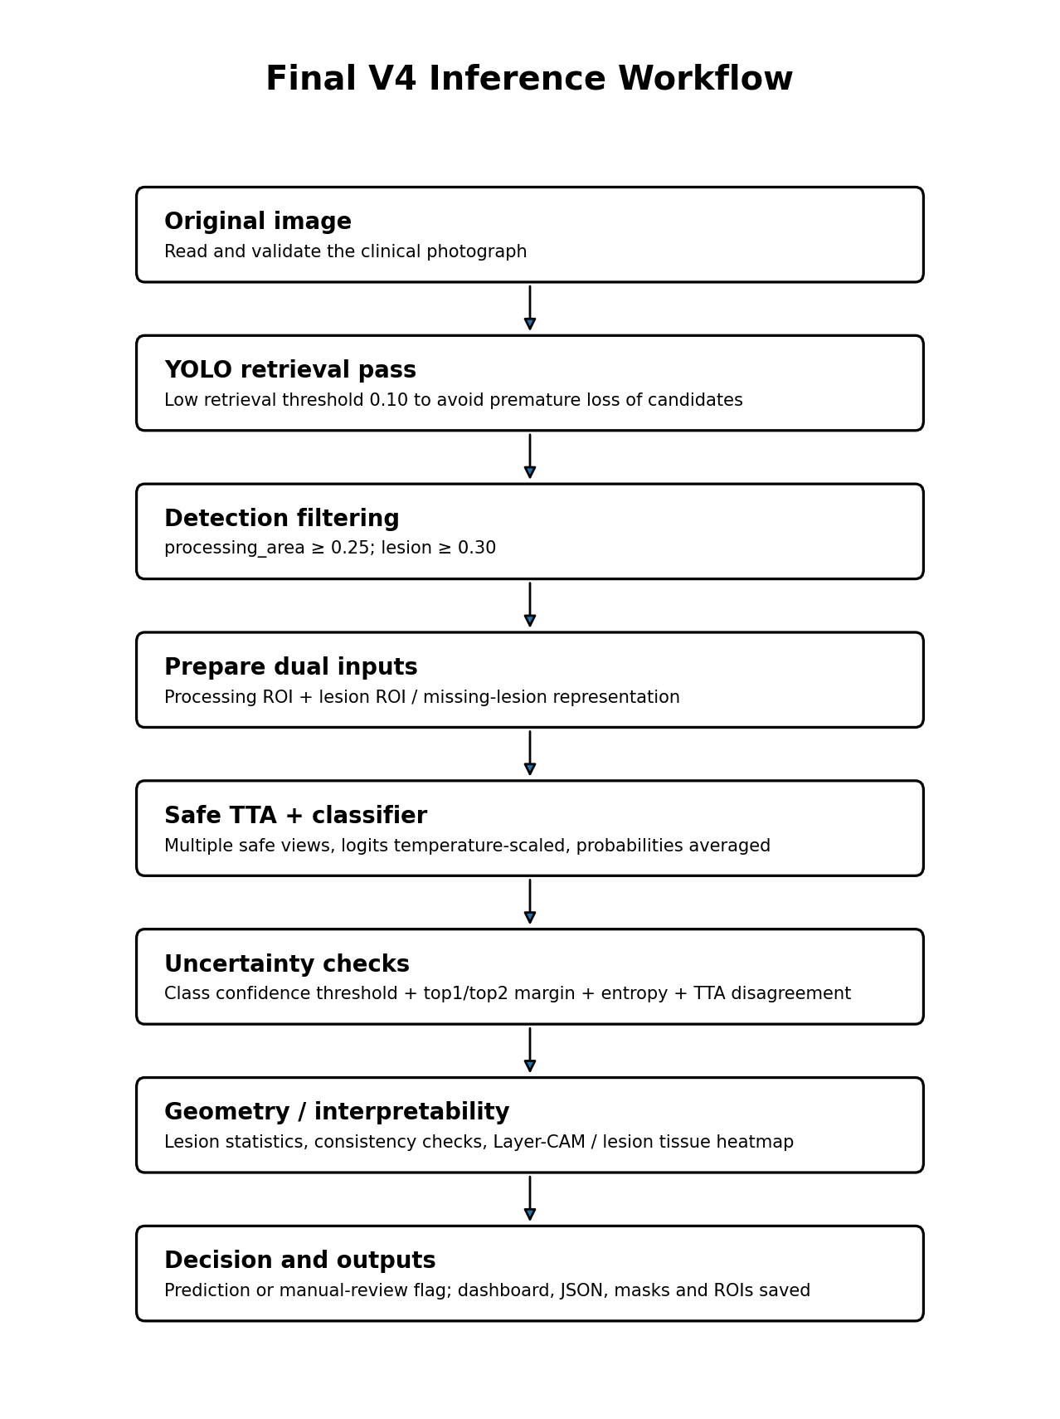
Inference control | Final value / behavior
YOLO retrieval threshold | 0.10
processing_area acceptance | ≥ 0.25
lesion acceptance | ≥ 0.30
Safe TTA | Enabled
Temperature scaling | Loaded from calibration JSON
Entropy threshold | Loaded from thresholds JSON
Top1–Top2 margin threshold | Loaded from thresholds JSON
Class-specific thresholds | Loaded per class from thresholds JSON
High TTA disagreement rule | > 0.08 triggers review reason

16. Segmentation Fallbacks During Final Inference
The classifier is designed to continue operating when detection is imperfect. If no processing-area mask is available, the code can use the full image as the processing input. If a valid lesion is unavailable, the model receives a missing-lesion representation and lesion_present = 0 instead of pretending that a lesion crop exists.
This is important because the segmentation model and classifier are coupled but the classifier is not allowed to fail simply because one ROI was absent.

17. Interpretability and Geometry
The upgraded V4 inference code adds more than class probabilities. It computes lesion-related geometry/statistics and produces Layer-CAM-style visual explanations. The later V4 variant also constrains a lesion-tissue heatmap to the segmented lesion region, so the visual explanation is localized to detected lesion tissue rather than spreading freely over the full frame.
- Processing-area mask and lesion mask can be saved.
- Processing ROI and lesion-context ROI are saved for audit.
- Lesion geometry / multi-lesion statistics are available to the report layer.
- Layer-CAM / lesion-tissue heatmap supports visual review of the classifier decision.
- Classifier reliability and segmentation quality signals are combined in the hard-case logic.

18. Final Output Produced for One Image
The final prediction function returns/saves a structured result rather than only a class label. The notebook documentation describes the following major outputs:
Output group | Examples
Classification | raw predicted class, final display result, top-1/top-2 probabilities, all four calibrated probabilities
Segmentation | processing-area and lesion detections, masks, confidence and boxes
Reliability | entropy, TTA disagreement, margin, class threshold, manual_review_required, reasons
Interpretability | Layer-CAM / lesion tissue heatmap
Artifacts | result folder, JSON report, dashboard, ROI images and masks

When reliability rules are not satisfied, the final display can become “Uncertain — Manual Review” instead of forcing a diagnostic class.

19. What Is Actually “Final” in the Notebook?
Item | Status
YOLO segmentation model | Single AI_Y1 model; supplies processing_area and lesion
Earlier classifier | Single-ROI EfficientNetV2-B3; completed run with recorded test metrics
Final classifier architecture | ImprovedDualROIEfficientNet / tf_efficientnetv2_b3
Final classifier checkpoint used by V4 | UPGRADE_BEST_F1_PATH (best Macro-F1 checkpoint)
Final deployment concept | AI_Y1 segmentation → dual ROI → AI_C1 → calibration/uncertainty/manual review

Important evidence note: the notebook preserves the complete upgraded model/training/inference code, but its output cells do not contain the completed Dual-ROI V2 training history or final test metric table. Therefore, this document does not invent final Dual-ROI accuracy/F1 values. The numeric performance table in Section 7 is specifically the earlier single-ROI baseline run.

20. Study Flow — Read This to Recall the Whole Project Quickly
1) Start with 3,692 labeled oral images across four diagnostic classes.
2) Hash every image; remove contradictory duplicate labels and same-class copies.
3) Keep 3,371 clean unique images and split 2,359 / 506 / 506 without exact-image leakage.
4) Run AI_Y1 YOLO to focus the classifier on oral processing tissue and lesion regions.
5) Baseline: train EfficientNetV2-B3 on one processing-area ROI; recorded test Macro-F1 = 0.7431.
6) Upgrade: feed processing ROI + lesion ROI to one ImprovedDualROIEfficientNet model.
7) Handle missing lesion with a learned embedding and learned lesion reliability gate.
8) Train in three stages with balanced sampling, label smoothing, lesion-branch dropout and EMA.
9) Select the best Macro-F1 checkpoint for the final V4 inference pipeline.
10) During inference, perform YOLO retrieval/filtering, safe TTA, temperature calibration and uncertainty checks.
11) Return a class only when reliability rules allow it; otherwise flag manual review.
12) Save auditable visual and structured outputs (ROIs, masks, heatmaps, dashboard, JSON).

21. Reproducibility Checklist
- Preserve classifier class order exactly: Cancer, Leukoplakia, Leukoplakia-like Conditions, Normal Buccal Mucosa.
- Preserve AI_Y1 segmentation mapping: processing_area = 0, lesion = 1.
- Use the cleaned leakage-safe manifest rather than rebuilding random splits from raw folders.
- Keep the 300×300 classifier input convention and the same evaluation normalization/transforms.
- Load final Dual-ROI architecture before loading its checkpoint; baseline and upgraded checkpoints are not interchangeable.
- Keep calibration JSON and thresholds JSON with the final checkpoint for production inference.
- If reporting scientific results, clearly distinguish baseline measured metrics from Dual-ROI metrics obtained in any later rerun.
- Archive notebook, manifests, YOLO weights, classifier checkpoint, calibration files and inference version together.

22. Final Technical Summary
OralScan is a two-model pipeline. AI_Y1 is the single segmentation model. AI_C1 is the single diagnostic classifier. The final AI_C1 design is dual-input, not dual-model: it jointly interprets processing-area context and lesion-specific evidence using one shared EfficientNetV2-B3 backbone and one fusion classifier head. The classifier was engineered for imperfect segmentation through explicit missing-lesion handling, lesion reliability gating, branch dropout, calibration, TTA and manual-review rules.
For future study, the most important conceptual distinction is: YOLO answers “where is the relevant tissue/lesion?”, while AI_C1 answers “which of the four diagnostic classes best matches the extracted visual evidence?” The final system combines both answers and adds reliability checks before presenting the diagnostic-support result.

